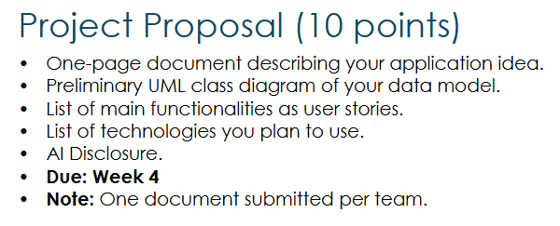
Clayton Brandt, Nathan McMichael, Toan Nguyen
Professor Roach
CSCI 3110-001
Due Date 17 September 2026
Packet Sniffers
Placeholder.

I don’t know what AI disclosure is. I don’t even know what AI is.

